|  |  |  |  |
| --- | --- | --- | --- |
| **F:\Learning bugs\Foundation Subjects\Dolly the Fly - Science.jpgLyng Primary School Knowledge Organiser** | | | |
| **Topic:** | **Science**  **Seasonal changes: How do the seasons change?** | Year 1 | Spring 1 |

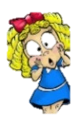

**Notable scientists**

**Liz Bentley**

“Spring is March, April, May; summer is June, July, August; autumn is September, October, November; winter is December, January, February. We keep it to whole months because it allows us to collate data and to compare one season to the next’’

**What should I already know?**

Notice that weather changes throughout the year.

Say the 12 months in the year.

|  |  |
| --- | --- |
| **What Step On and Goldilocks words will I use?** | |
| **Spelling** | **Definition** |
| weather | The condition of the air outside at a certain place and time, such as sunny, rainy, or snowy. |
| temperature | How hot or cold something is. |
| thermometer | A tool used to measure temperature. |
| season | One of the four times of the year (spring, summer, fall, winter) with different weather patterns. |
| evergreen tree | A tree that stays green and keeps its leaves all year round. |
| deciduous tree | A tree that loses its leaves in the fall and grows new ones in the spring. |
| data | Information collected about something, often in numbers or facts |
| conclusion | A decision or answer reached after thinking about the data and information. |
| pictogram | A picture that represents an idea or a piece of information. |

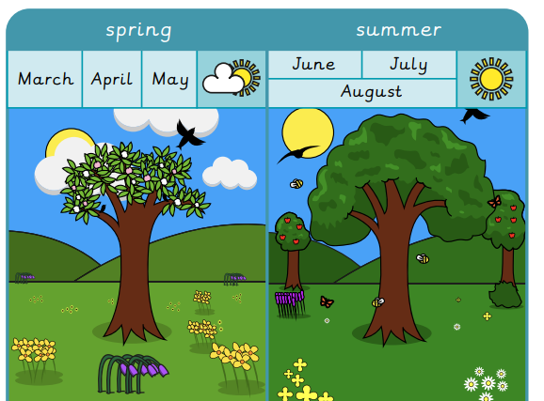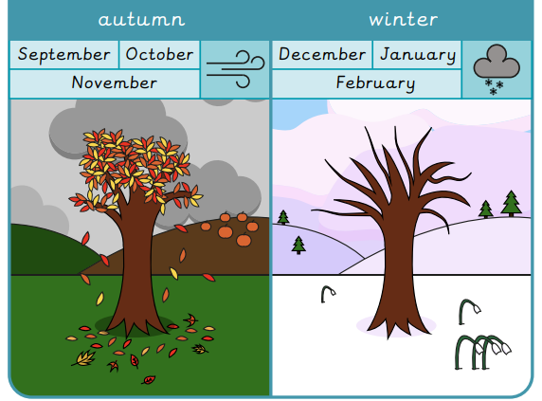

|  |
| --- |
| **Investigate!** |
| The weather changes throughout the year. The weather is usually warmest in the summer and coldest in the winter.  We have fun events and festivals in the 4 seasons including Christmas in the winter and bonfire night in the autumn.  The leaves change in deciduous trees.  Day light changes with each season. |
| **Enquiry Questions** |
| * How does the weather change across the 4 seasons? * What events and activities can we do in the 4 seasons? * How do trees change? * How do daylight hours change? * What are the changes across the 4 seasons? * How do we make a weather report? |

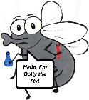

**What will I know by the end of the unit?**

|  |
| --- |
| Children will… |
| Work together to name the 4 seasons and describe the weather changes. They will make a weather report in a group. They will record each other pointing to different parts of the UK and describing the weather. |
| * Name the four seasons in order and describe the typical weather in each. * Name some activities and events in the four seasons. * Describe the appearance of a tree’s leaves in each season. * Recall that summer has the most daylight hours and winter has the least daylight hours. * Record data about the temperature across the four seasons. * Label a map of the UK with capital cities and seasonal weather symbols. |
| * Complete a pictogram and use it to answer simple questions. * Record data about the temperature across the four seasons. |

|  |  |  |  |
| --- | --- | --- | --- |
| **F:\Learning bugs\Foundation Subjects\Dolly the Fly - Science.jpgLyng Primary School Knowledge Organiser** | | | |
| **Topic:** | **Science**  **Seasonal changes: How do the seasons change?** | Year 1 | Autumn 1 |

|  |  |  |
| --- | --- | --- |
| 4. In spring … | **S** | **E** |
| Lambs are born |  |  |
| Some people build snowmen |  |  |
| It is bonfire night. |  |  |

|  |
| --- |
| 5. Which season is this? |
| **S** |
| **E** |

|  |  |  |
| --- | --- | --- |
| 1. Which season has the fewest daylight hours? | **S** | **E** |
| Spring |  |  |
| Summer |  |  |
| Winter |  |  |

|  |  |  |
| --- | --- | --- |
| 1. In autumn… | **S** | **E** |
| Some trees grow blossom. |  |  |
| The leaves on some trees change colour. |  |  |
| Some trees grow bright green leaves. |  |  |

|  |  |  |
| --- | --- | --- |
| 1. Which season has the warmest weather? | **S** | **E** |
| Spring |  |  |
| Summer |  |  |
| Winter |  |  |